**HTML TAGS & SEMANTICS**

The semantics and hierarchical structure of the HTML document is important for a variety of reasons:

1. The content is organized.
2. It’s accessible without the need of vision.
3. Web page is optimized for search engines.

HTML Document

Every HTML document has a basic structure which is required to be valid.

<!DOCTYPE html> (defines type of document)

<html lang=”en”>

<head>

<meta charset=”UTF-8”> (tells the browser about the encoding of the characters)

<title>Document</title> (title of the website displayed on top of the tab in the browser, not on the page)

</head>

<body> (main body and what we see in our browsers)

</body>

</html>

* The <html></html> tag has two child tags <head></head> is the **brain** of the document, this is where we add **the information about the document and links to the stylesheets which are the CSS documents**. This information is mainly for use of the browsers and is mostly not displayed to the users.
* Meta charset and title tags should always be used on the head.
* UTF-8 encoding covers many languages in the world.
* <!-- --> is a comment element used for adding invisible notes.

Parent-child relation

Parent: the element that contains other elements.

Child: the element that is inside another element.

Sibling: the element that is also inside the same parent element.

For ex.:

<head> </head> is the parent.

<meta charset=”UTF-8”> and <title></title> are the children of <head></head>

<meta charset=”UTF-8”> and <title></title> are siblings.

Indentation

We use indentation to properly structure the code. Makes the reading easier. (using *tab* key)

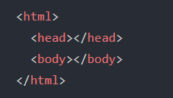

Page layout

Page layout semantic tags are used to give specific meaning to the parts of our page, such as the main article, header, footer, navigation, different sections of the page, etc.

<header> when used as the child of <body> acts as the master header of the page.

When added inside the <article> tag it acts as the header of the article.

<footer> when used as the child of <body> tag it acts as the footer of the web page. When added inside the <article> tag it acts as the footer of the article.

<nav> is the navigation page, this will contain links to other pages of the website.

<main> primary content of the page

<article> is the tag for containing an independent piece of content.

<aside> secondary content on the page, this information is not part of the main topic of the page. Optional.

<section> group of related content on the page. A section must have its own heading.

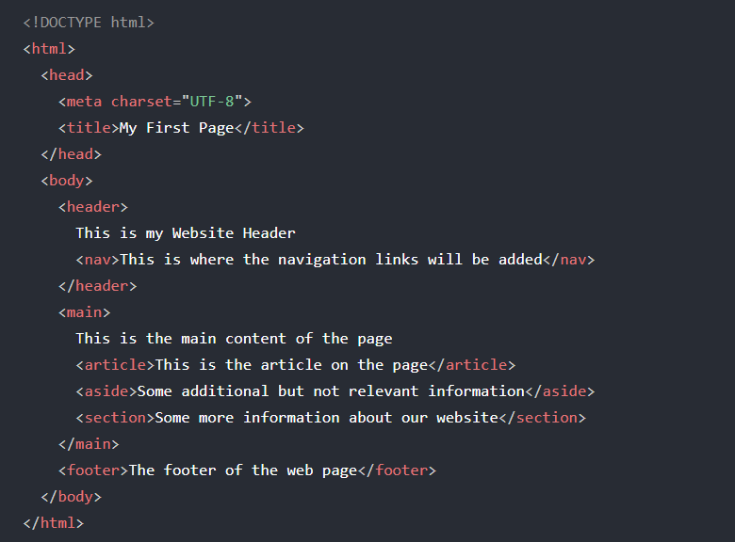

Generic tags

<div> is used to wrap around multiple child elements. Div divides the content into logical groups which will show the content on a separate line.

<span> is used for single elements or short pieces of content. Span shows the content inline with the rest of the content.

Text Semantics

Text semantics tags allow us to give semantic meaning to the text. The content of these tags is styled by the browser to visually display the text differently.

* Headings: <h1>, <h2>, <h3>, <h4>, <h5> and <h6>. (biggest to smallest size)
* Paragraphs: <p> (the browser will add a space before and after the paragraph).
* Quote: <q>
* Blockquote: <blockquote> (stand-alone quote)
* Citation: <cite> (citation from another source. A person’s name or title)
* Emphasis: <em> (italic text)
* Important text: <strong> (bold text)
* Abbreviation: <abbr title=”…”> (abbreviation)
* Highlighting: <mark> (to highlight text)
* Technical term: <i> (italic text for titles, words in another language, book names, etc)
* <b> (defines a keyword in bold)
* Subscript text: <sub> (H20)
* Superscript text: <sup> (10th)
* Deleted content: <del datetime=”…”> (content ~~deleted~~)
* Address: <address> (contact information, email, tel, address)
* Line break: <br> (creates a line break)
* Horizontal line: <hr> (represents a thematic break in the content)

**HTML Lists**

3 types of lists.

1. Unordered list: do not have a specific order.

Opening tag - <ul> </ul>

Inside the opening tag we add each list item - <li> </li>

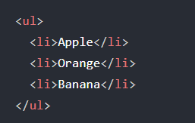

1. Ordered list: the order is important.

Opening tag - <ol> </ol>

Inside the opening tag we add each list item - <li> </li>

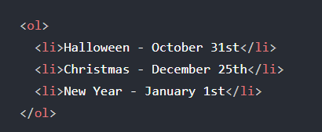

1. Description list: Type of list where we have a term and a description of the term.

Opening tag - <dl> </dl>

Inside we add the info using 2 tags.

* + - <dt> </dt> description term.
    - <dd> </dd> Description of the term

